Chicken Fajita Quesadillas

Ingredients
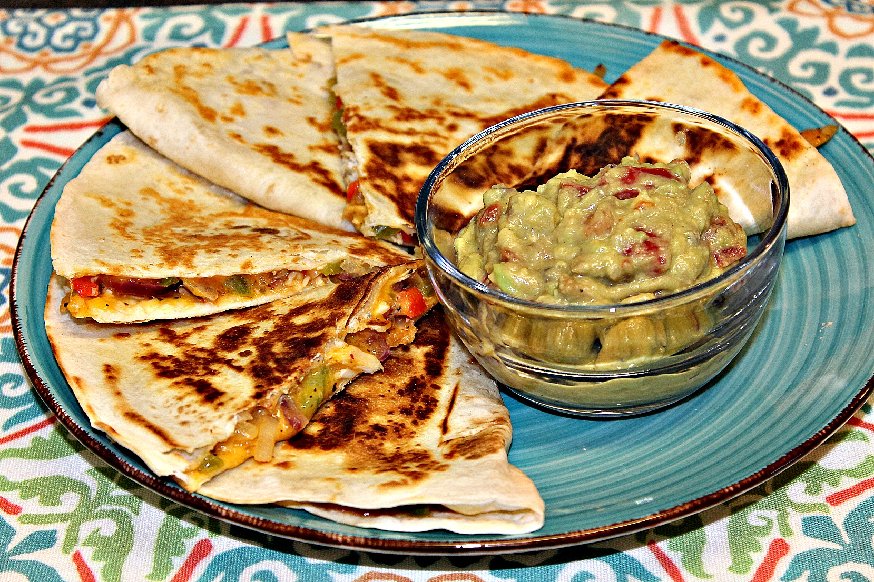
2 Chicken breasts
1 Green bell pepper
1 Red bell pepper
1 Red onion
1 Yellow onion
2 Tbsp. olive oil (divided)
1 ½ Cup shredded cheddar (or Mexican blend)
5 – 6 Large flour tortillas
1 Tsp. lemon pepper
Salt and pepper (to taste)
½ Tbsp. butter
Instructions
- Season the chicken breasts with salt and pepper (I like to use seasoned pepper).
- Pour 1 tbsp. of olive oil in a skillet on medium heat.
- Once oil is hot, sauté chicken until it’s done (About 5 – 7 minutes on both sides).
- While chicken is cooking, julienne cut the bell peppers and onions.
- Place the vegetables in a large bowl; add lemon pepper, salt, pepper, and 1 tbsp. oil; mix together.
- Once chicken is done, place chicken on a plate and shred with two forks.
- Add vegetables to the skillet and sauté until softened but still has color (about 5 minutes).
- Return vegetables back to the large bowl; add in shredded chicken.
- Add cheese to the mixture and stir.
- Grab your tortillas. Spoon the filling on half of each tortilla.
- Sprinkle more cheese on top and fold the other side of the tortilla over it.
- Place butter in a griddle pan or skillet on medium heat.
- Once butter is melted, place your quesadillas in and brown on both sides (3 – 5 minutes per side).
- Remove quesadillas from the pan and cut into thirds.
- Serve and enjoy!
Tip: Serve these with guacamole, salsa, or sour cream with sliced green onions!

