Easy Shepherd’s Pie
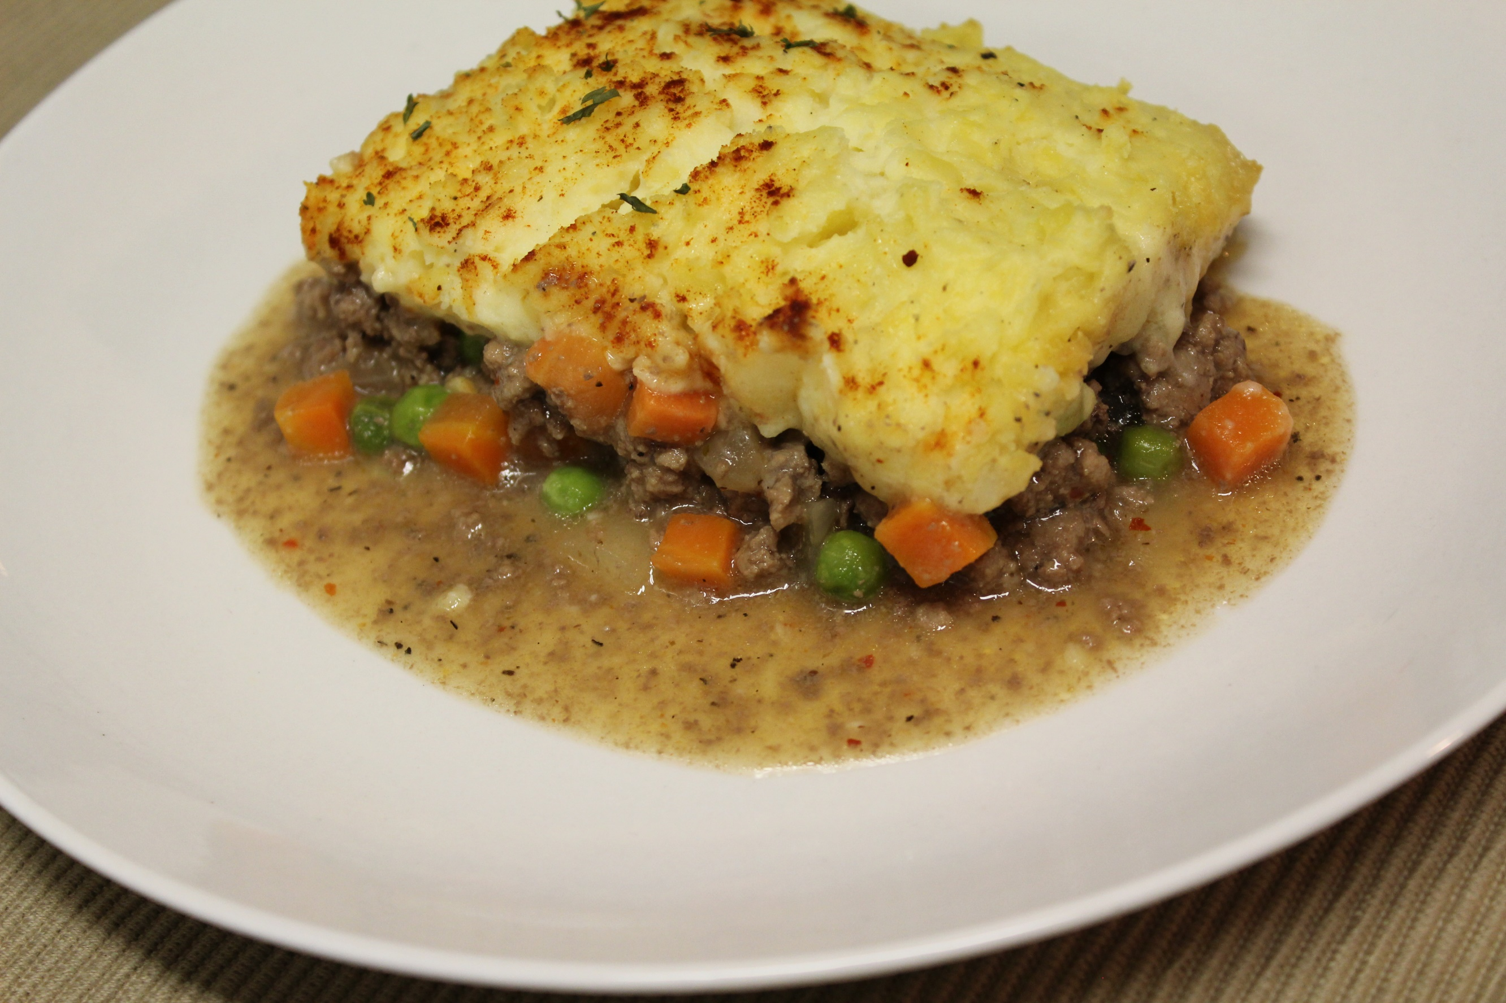
Ingredients:
2 lbs ground beef
1 yellow onion
1 teaspoon garlic powder
1 teaspoon Cajun seasoning
1 teaspoon salt (optional)
Several dashes of seasoned pepper (to taste)
1 cup beef broth
2 tablespoons cornstarch slurry
1 bag (12oz) frozen peas and carrots
Paprika (optional)
Parsley flakes (optional)
(For potatoes)
2 - 3 lbs yellow potatoes
1 (8oz) package of cream cheese
1 stick of butter (or desired amount)
1/2 cup whole milk (or half & half)
Instructions:
1. Brown ground beef in a deep skillet.
2. Add in diced onions while meat continues to brown.
4. Add in garlic powder, Cajun seasoning, salt, and pepper.
5. Continue to simmer for about 5 - 7 minutes.
6. Pour in beef broth and cornstarch slurry (2 tbsp cornstarch mixed with 2 tbsp of cold water.
7.Simmer for about 15 minutes to allow gravy to thicken.
(To prepare mashed potatoes)
* Cover potatoes with water in a pot. Boil on medium high heat for about 25 minutes or until potatoes are fork tender. Drain. Place potatoes in a bowl and mash with a potato masher. Add in softened cream cheese, softened butter, and room temperature milk (or half & half). Add in salt, pepper, and garlic powder and mix until creamy.
8. Pour meat mixture into a baking dish.
9. Add in desired amount of frozen peas and carrots and stir.
10. Flatten mixture so that it's even.
11. Spoon on potatoes and spread out evenly with a fork.
12. Sprinkle top with paprika and parsley flakes (for color)
13. Bake at 400 degrees for 20 - 25 minutes or until golden brown.
14. Serve and enjoy!

