Street Tacos (Beef)

Ingredients:
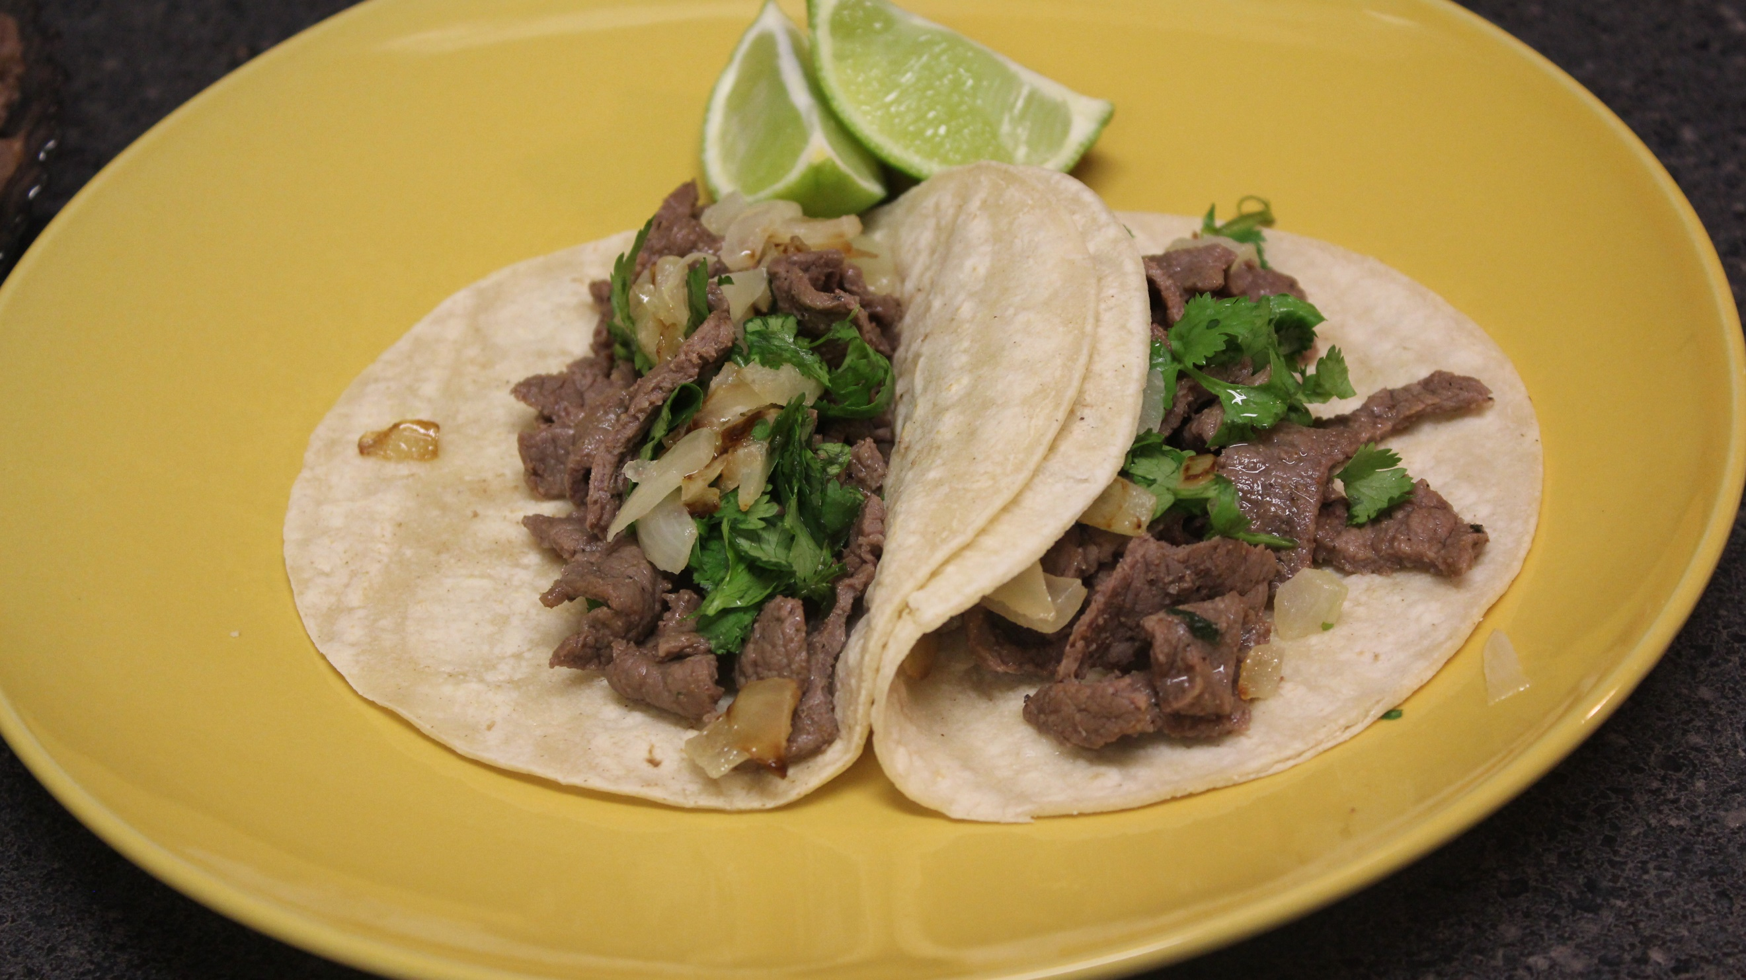
1 lb thinly sliced skirt steak (or flank)
1 Tbsp olive oil
1 cup orange juice
1 lime, juiced
2 Tbsp chopped cilantro
1 tsp salt
1 tsp pepper
2 tsp cumin
5 garlic cloves, cracked
10 small white corn tortilla (or flour tortillas if you prefer)
3 – 4 limes cut into quarters
1 – 2 onions, chopped
Fresh cilantro, chopped

Instructions:
- Place steak in a large freezer bag.
- In a bowl, mix together olive oil, orange juice, lime, cilantro, salt, pepper, cumin, and garlic.
- Pour in the bag and refrigerate (marinate) for several hours (at least 2).
- Place meat in a skillet on medium high heat and cook until brown. (You can also grill your meat if you desire but I recommend using a whole steak as opposed to thinly sliced steak if you choose to grill. Then slice against the grain.)
- Heat your tortillas up on medium heat. (You can add butter if you desire.)
- Store tortillas in foil to keep them warm.
- Build your taco! Place desired amount of beef on a tortilla. Sprinkle on some fresh cilantro and onions (I like my onions sautéed until golden brown). Squeeze some lime juice on top.
- Enjoy!

