Collard Greens & Ham Hocks
Ingredients
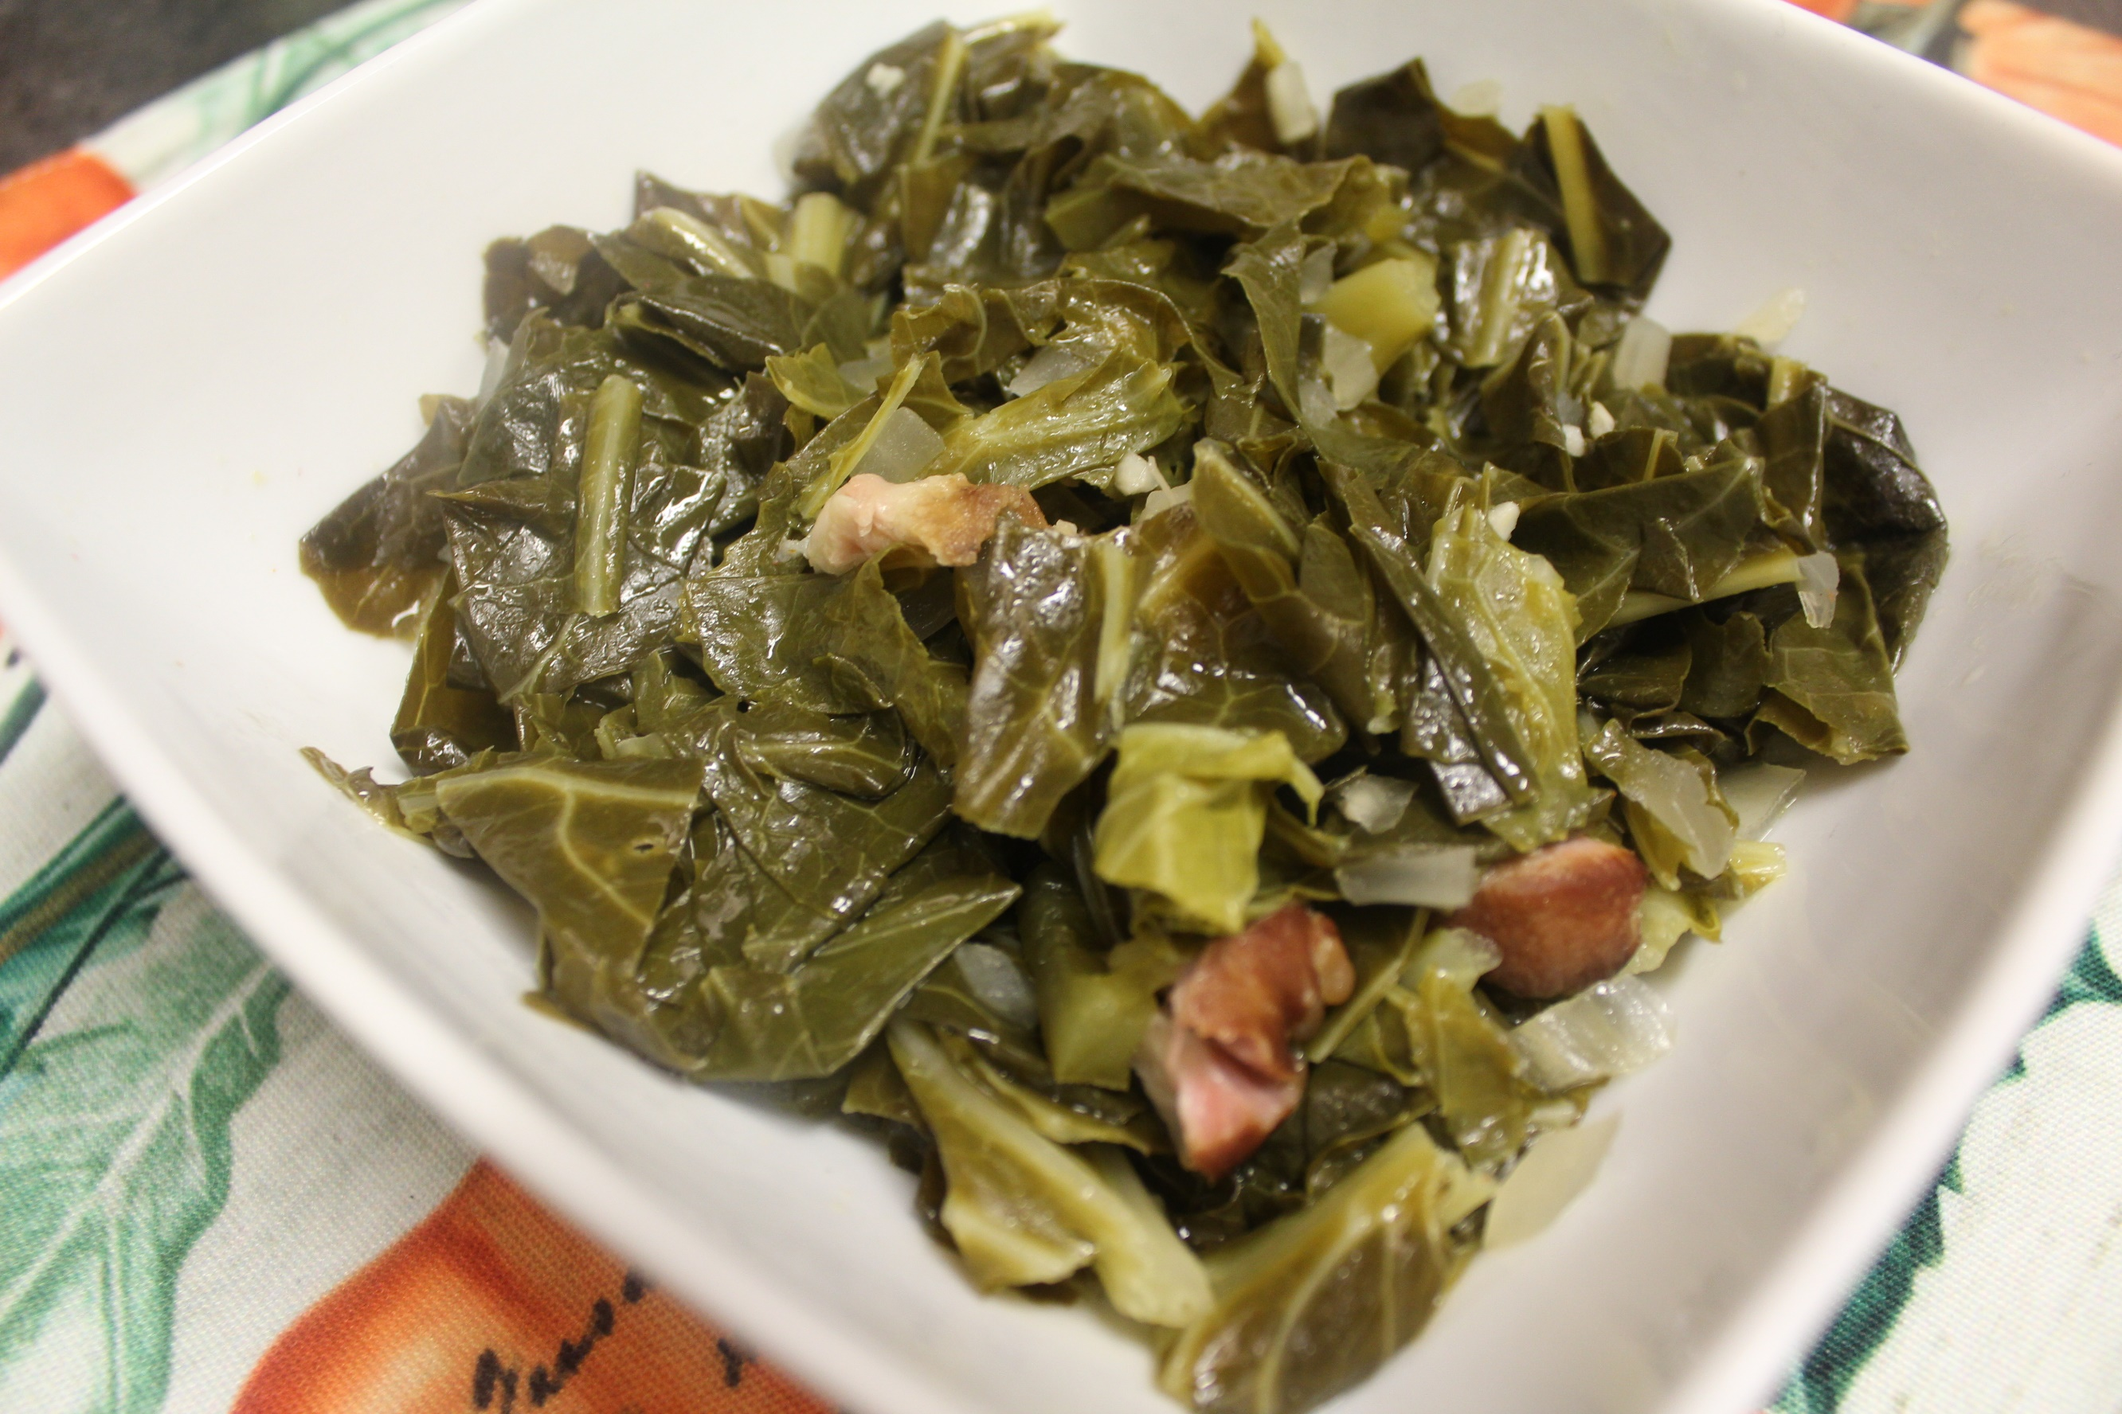
2 Large ham hocks
1 Diced yellow onion
1 jalapeno (optional)
1 Tbsp. minced garlic
8 cups of water
2 lb collard greens
2 Tbsp. apple cider vinegar
1 Tbsp. seasoned salt (or to taste)
1 Tbsp. pepper (or to taste)

Instructions:
- Place ham hocks in your slow cooker.
- Add in onion, diced jalapeno, minced garlic, and water.
- Cook on high for 4 hours.
- Rinse and cut your collard greens.
- Add collard greens, apple cider vinegar and seasonings to your slow cooker.
- Cook on high for another 2 hours.
- Serve and enjoy!

