Taco Spaghetti

Ingredients:
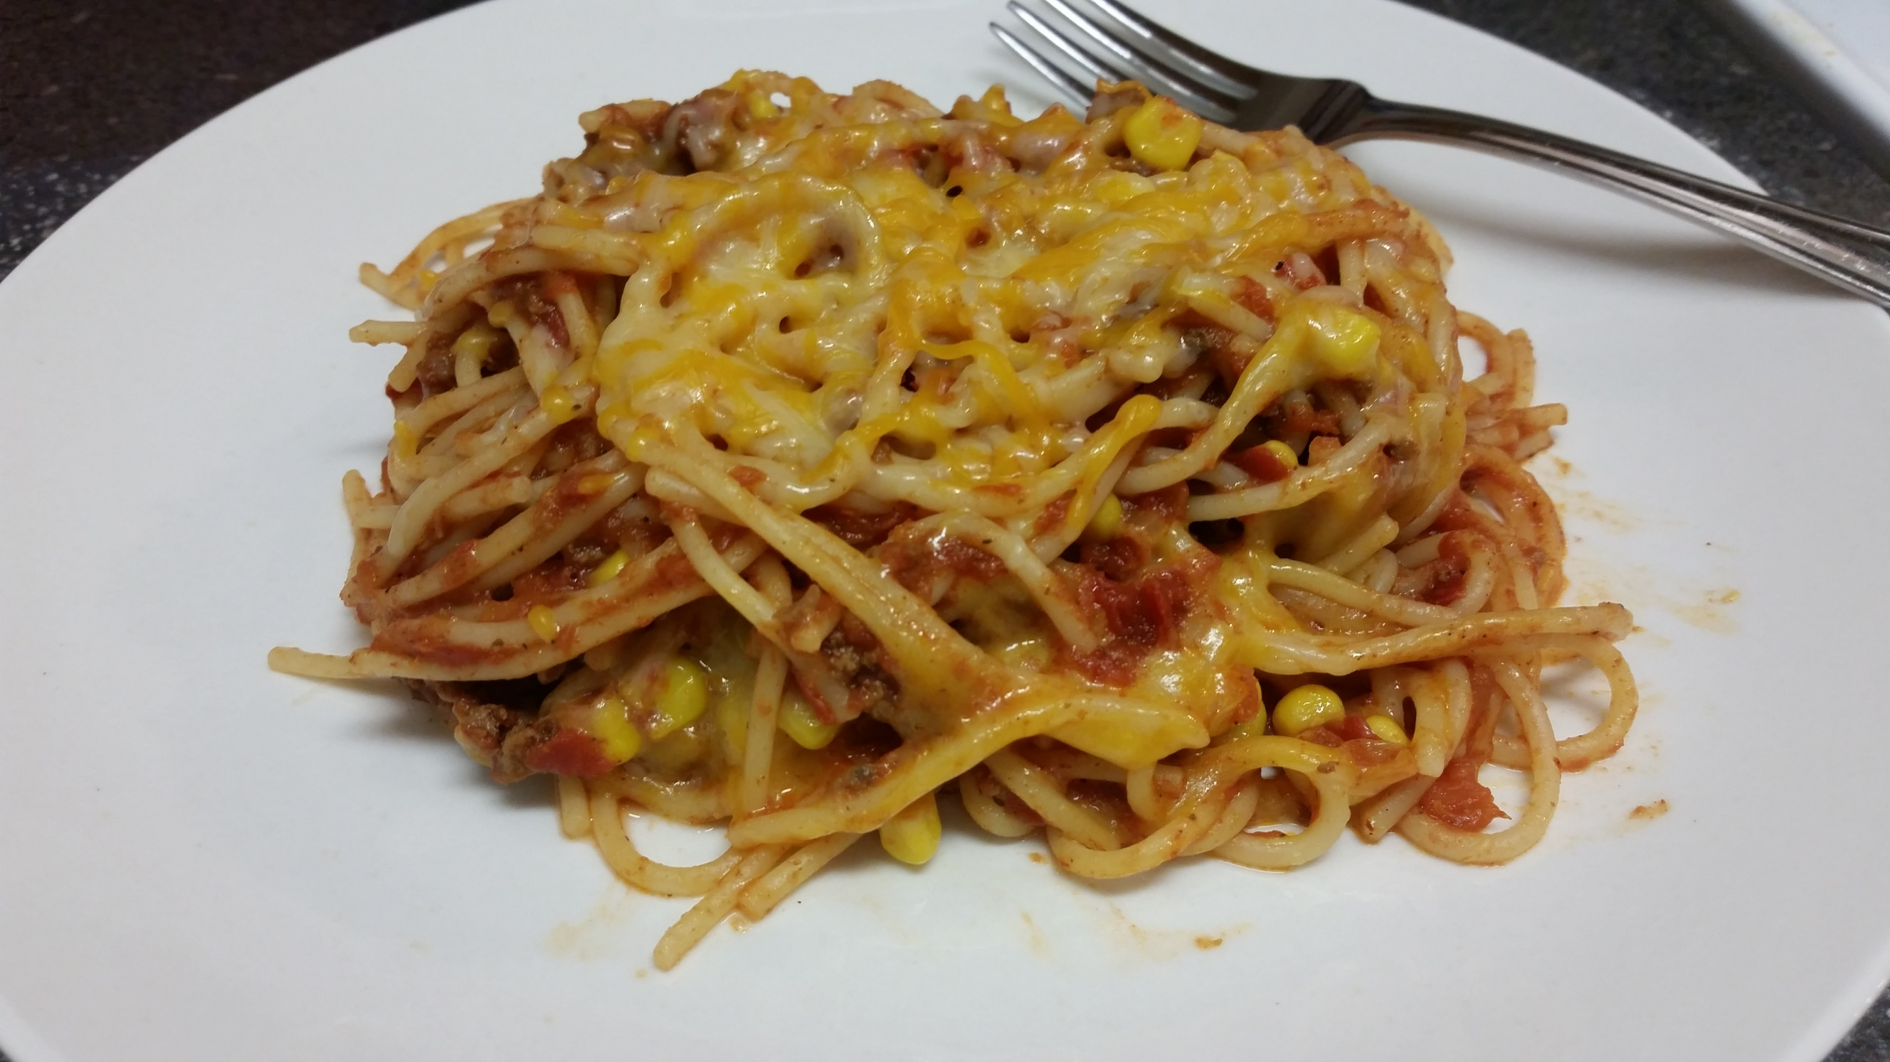
1 lb ground beef
1 package McCormick taco seasoning
¾ cup water
1 can (28 oz) crushed tomatoes
1 can (15.25 oz) whole kernel corn
½ tsp salt
½ tsp pepper
1 tsp cumin
½ lb spaghetti noodles
1 – 2 cups Monterey jack/ Colby cheese blend (or Mexican blend)

Instructions:
- Brown meat on medium heat; Drain.
- Add ¾ cup of water and taco seasoning.
- Bring to a boil, lower heat and let simmer about 5 minutes.
- Add in crushed tomatoes, corn, salt, pepper and cumin.
- Stir, cover and let simmer until hot.
- Bring a large pot of water to a boil on medium high heat.
- Cook your noodles per package directions.
- Add meat mixture to your noodles and stir.
- Top with a generous amount of cheese.
- Cover pot to allow cheese to melt.
- Serve and enjoy!

