Crispy Buttermilk Chicken Tenders

Ingredients:
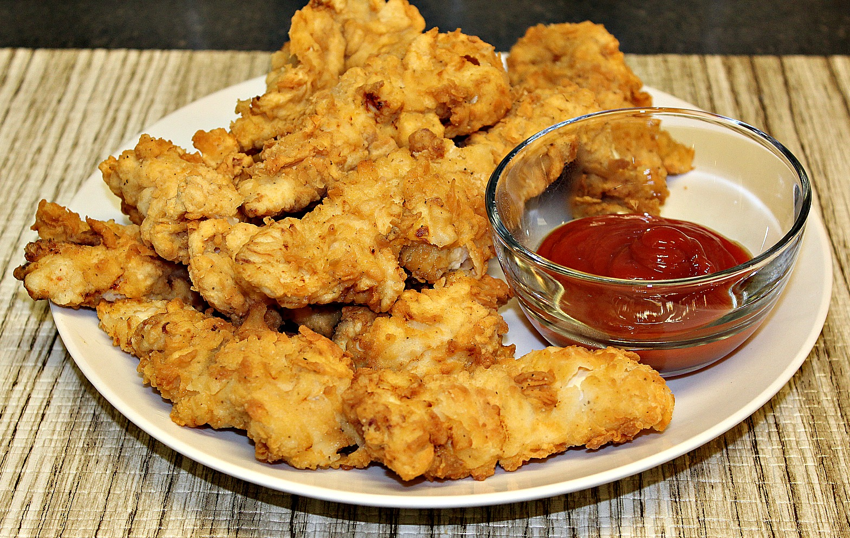
3 cups buttermilk
¼ cup hot sauce (more if you like a little heat)
2 lbs chicken tenders
1 tsp. salt
1 tsp. pepper
2 eggs
1 tsp. Cajun seasoning (or whatever seasonings you prefer)
4 cups all-purpose flour

Instructions:
- Pour buttermilk into a large bowl.
- Add hot sauce, salt, pepper and Cajun seasoning; stir.
- Submerge chicken tenders in buttermilk mixture.
- Cover the bowl and leave in the refrigerator overnight.
- Remove chicken from the buttermilk mixture.
- Beat eggs and stir into the buttermilk.
- Dredge tenders in the buttermilk then coat with flour and repeat (dredge and coat with flour twice).
- Fry chicken in a deep fryer at 350 degrees for 5 – 7 minutes or until golden brown.
- Serve and enjoy!

