Fried Okra
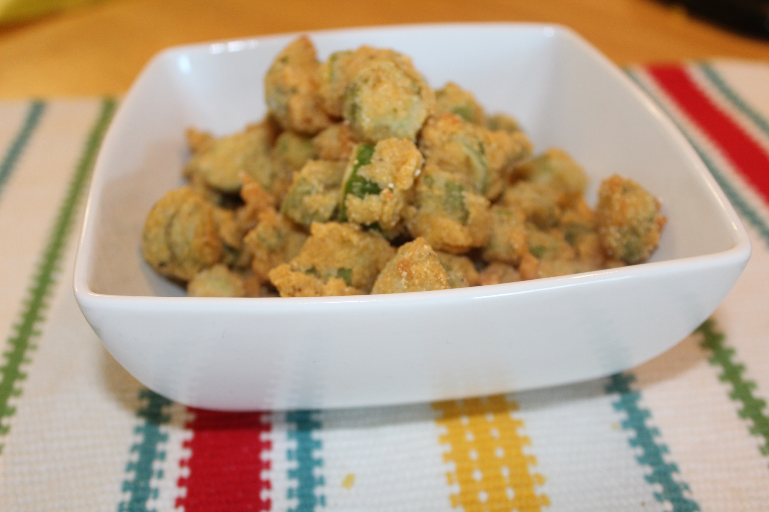
Ingredients:
1 bag of frozen okra slices, thawed (or you can use fresh)
1 egg beaten
1/2 cup corn meal
1/2 cup all-purpose flour
1/2 tsp salt
1/2 tsp pepper
1/2-1 cup of vegetable oil
​
​
Instructions:
1. In a small bowl, place okra in egg for a few minutes.
2. In a separate bowl, mix cornmeal, salt, and pepper.
3. Dredge okra in the cornmeal mixture, make sure it's evenly coated.
4. Heat oil over medium high heat.
5. Place okra in hot oil; stir continuously.
6. Once okra starts to brown, reduce heat to medium and cook until golden brown.
7. Drain on paper towels and enjoy!

