Old Fashioned Banana Pudding

Ingredients
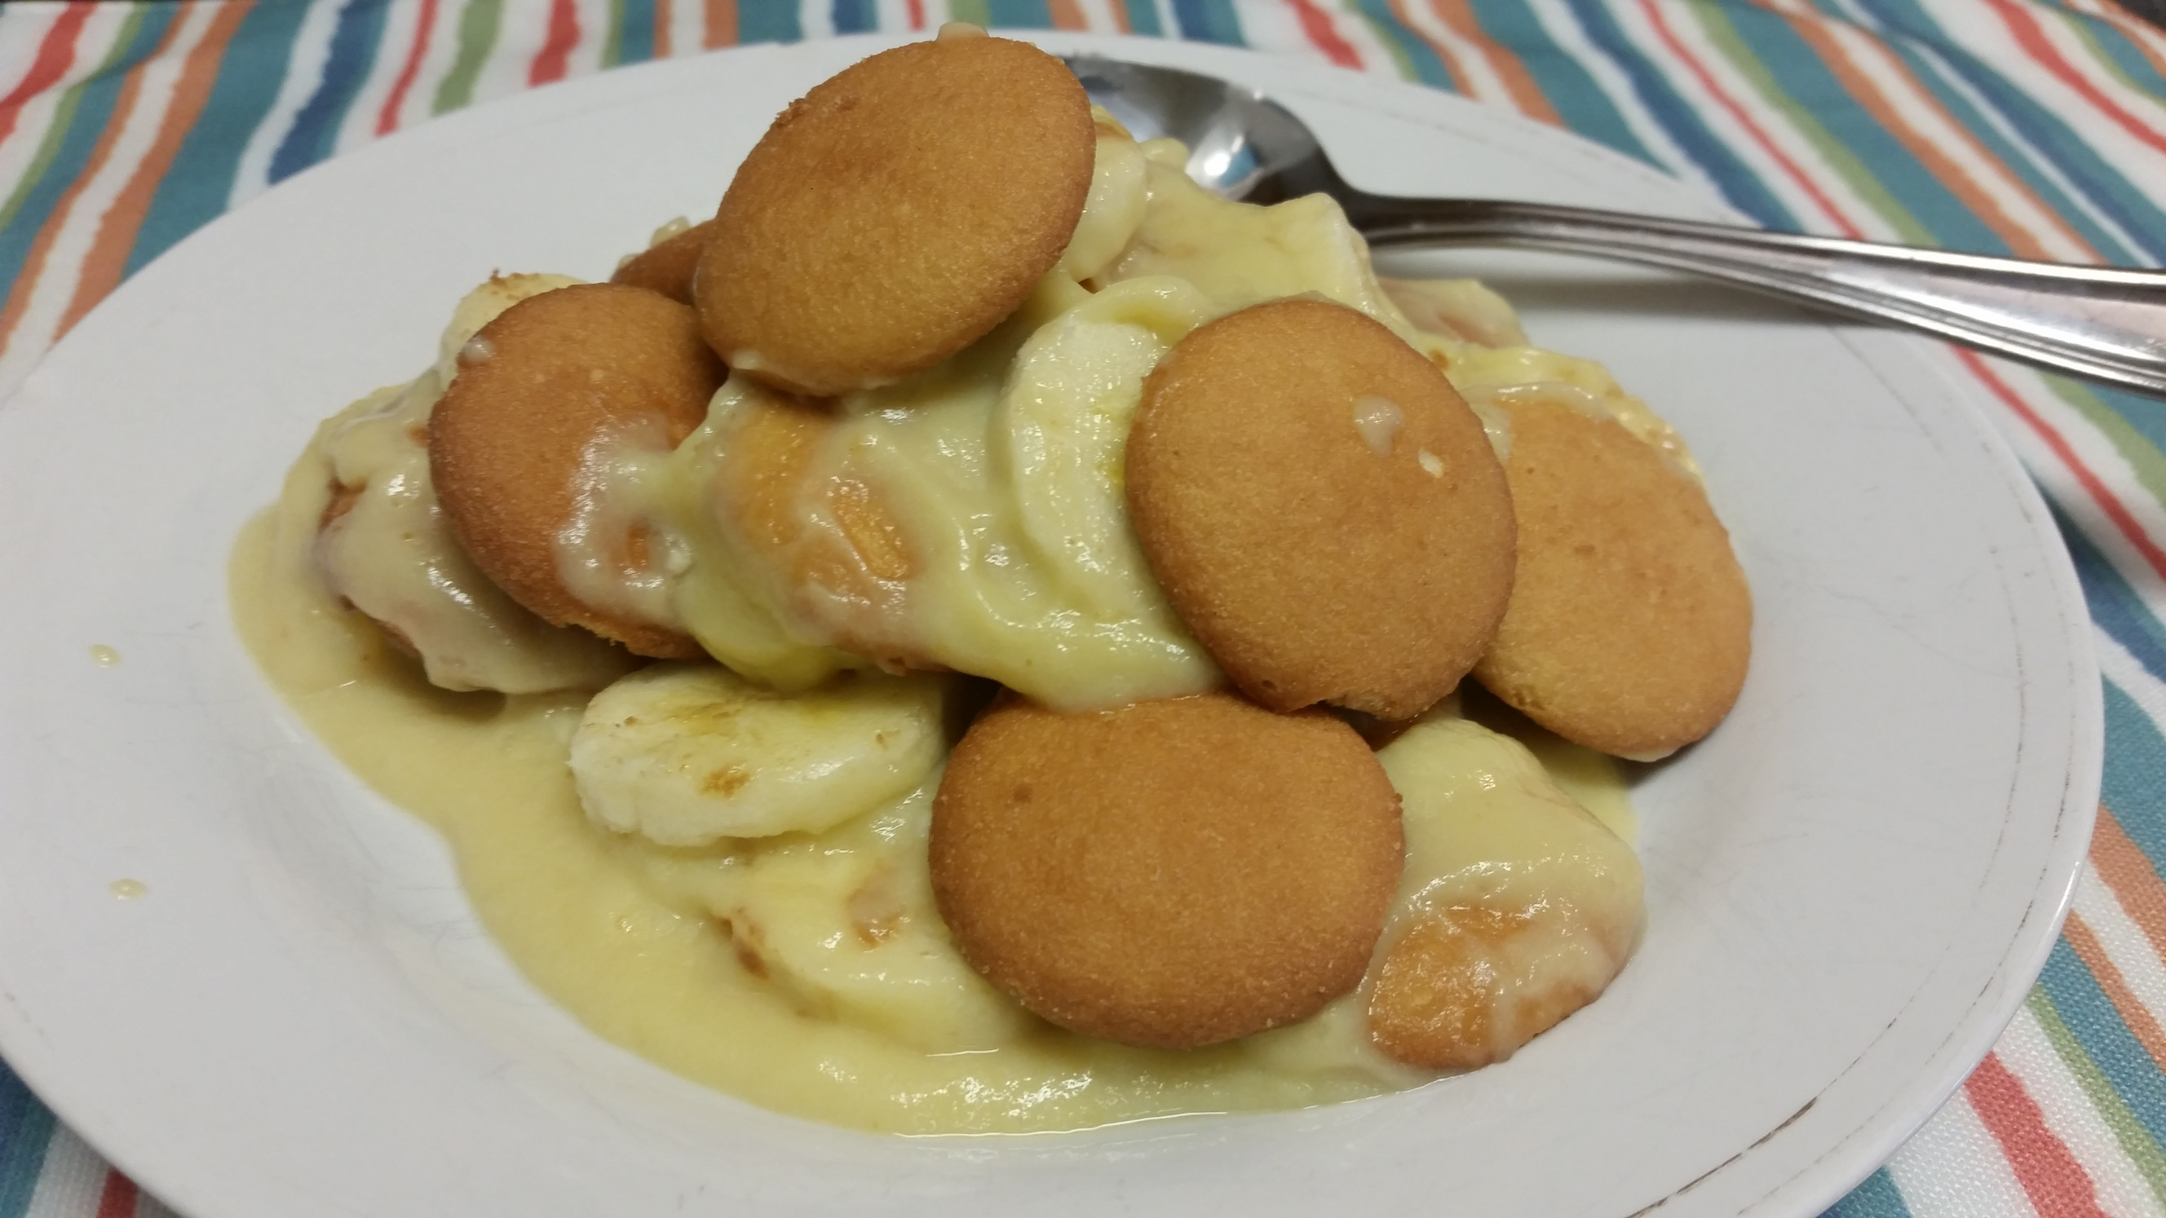
2 cups whole milk
3/4 cup sugar
pinch of salt
3 egg yolks, beaten
2 Tbsp cornstarch
2 Tbsp vanilla extract
2 - 3 Bananas
1 box Nilla Wafers

Instructions
1. Boil water on medium high heat in a double boiler.
2. Pour milk, sugar and salt together with a whisk.
3. Add in eggs, stir. Then add cornstarch.
4. Stir frequently until thickened.
5. Remove from heat. Add in vanilla and mix well.
6. Grab a small baking dish.
7. Cover the the bottom of the dish with the mixture.
8. Top with desired amount of sliced bananas then top with nilla wafers.
9. Repeat.
10. Serve and enjoy!

