Burrito Bowls

Ingredients
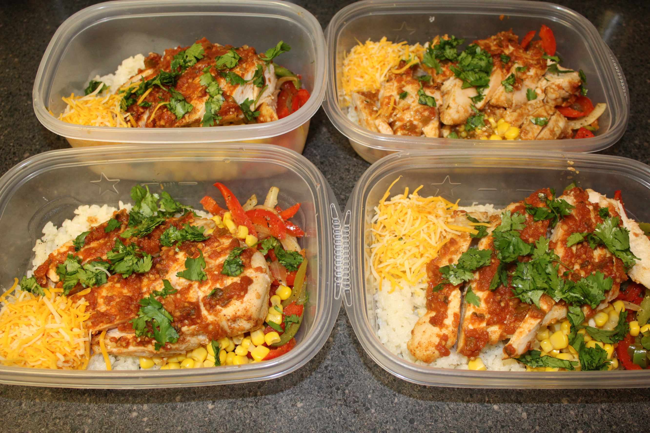
4 boneless, skinless chicken breasts
1 package of taco seasoning
1 cup (approx.) salsa
1 cup of rice
2 Tbsp. olive oil
1 red bell pepper (or orange or yellow), sliced
1 green bell pepper, sliced
1 yellow onion, sliced
1 can of corn
1 can of black beans
1 1/2 cup of Mexican blend shredded cheese
1/2 cup cilantro, chopped

Instructions:
1. Preheat oven to 400 degrees.
​2. Place chicken breasts on a foil lined baking sheet (or you can use a glass baking dish).
3. Sprinkle both sides with taco seasoning; rub it in so it's fully covered (you won't need the whole package).
4. Pour 2-3 Tbsp. of salsa on each chicken breast.
5. Place in the oven and bake for 25 minutes.
6. While that's cooking, prepare your rice (you can use brown or white). Follow the instructions on the back of the rice bag.
7. Pour oil in a skillet and put the heat on medium-high.
8. Place bell peppers and onion in the skillet. Cook until slightly wilted.
9. Now it's time to assemble your bowls! Grab four plastic containers.
10. Evenly distribute the rice into the bowls.
11. Top with desired amount of bell peppers, onion, corn, black beans, and shredded cheese.
12. Slice your chicken breasts up and place on top of each bowl.
13. Sprinkle with cilantro and place lids on your containers.
14. Grab 'em and go! (Or you can plate them and eat it for dinner!)
* I like my burrito bowls with guacamole and a lemon wedge.
* You can store these in the refrigerator for up to 4 days.

