Catfish Subs
Ingredients:
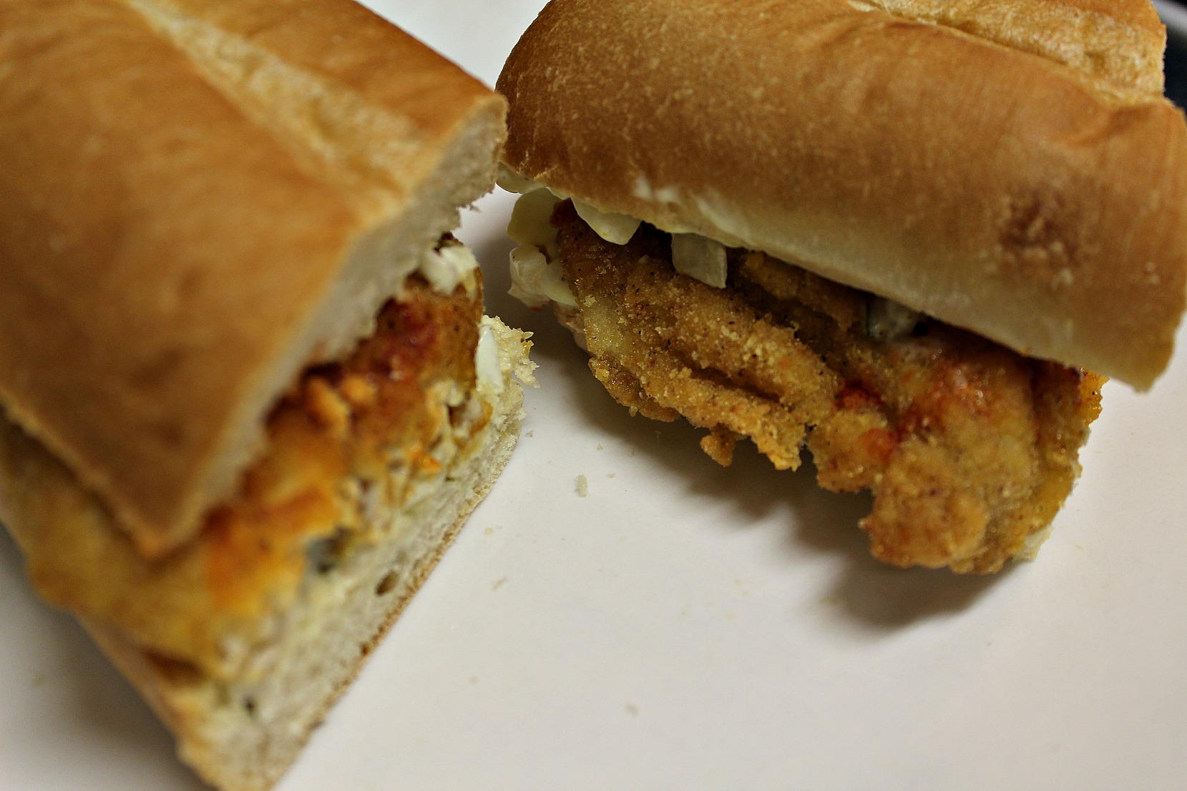
1 bag catfish fillets
1 bag Louisiana fish fry
Vegetable oil for frying
4-6 sub rolls
(For tartar sauce)
1 yellow onion (chopped)
4 Tbsp mayonnaise
1 ½ Tbsp dill relish
1 tsp mustard (approx.)
Salt and pepper to taste

Directions:
- Rinse fish with water. Pour fish fry into a freezer bag (or plate).
- Place the fish (2 or 3 at a time) in the freezer bag and coat each fillet evenly.
- Pour oil in a deep fryer and heat to 350 degrees.
- Lower your baskets into the oil (to prevent fish from sticking), then add your fish. (You may have to do this in batches.)
- Fry for 5-6 minutes.
- Set on a paper towel lined plate.
(Tartar Sauce)
- Place chopped onion in a small bowl.
- Add mayonnaise, relish, mustard, salt, and pepper. Mix well. (adjust to your taste)
Let’s build our sandwiches!
- Place roll on a plate.
- Spread desired amount of tartar sauce on both sides of the bread.
- Add two fish fillets.
- (Optional) Drizzle on some Louisiana hot sauce.
- Place the top of the roll on top and cut down the middle.
- Serve and enjoy!

