Cheesy Breakfast Quesadillas
(makes 4 – 6 quesadillas)
Ingredients:
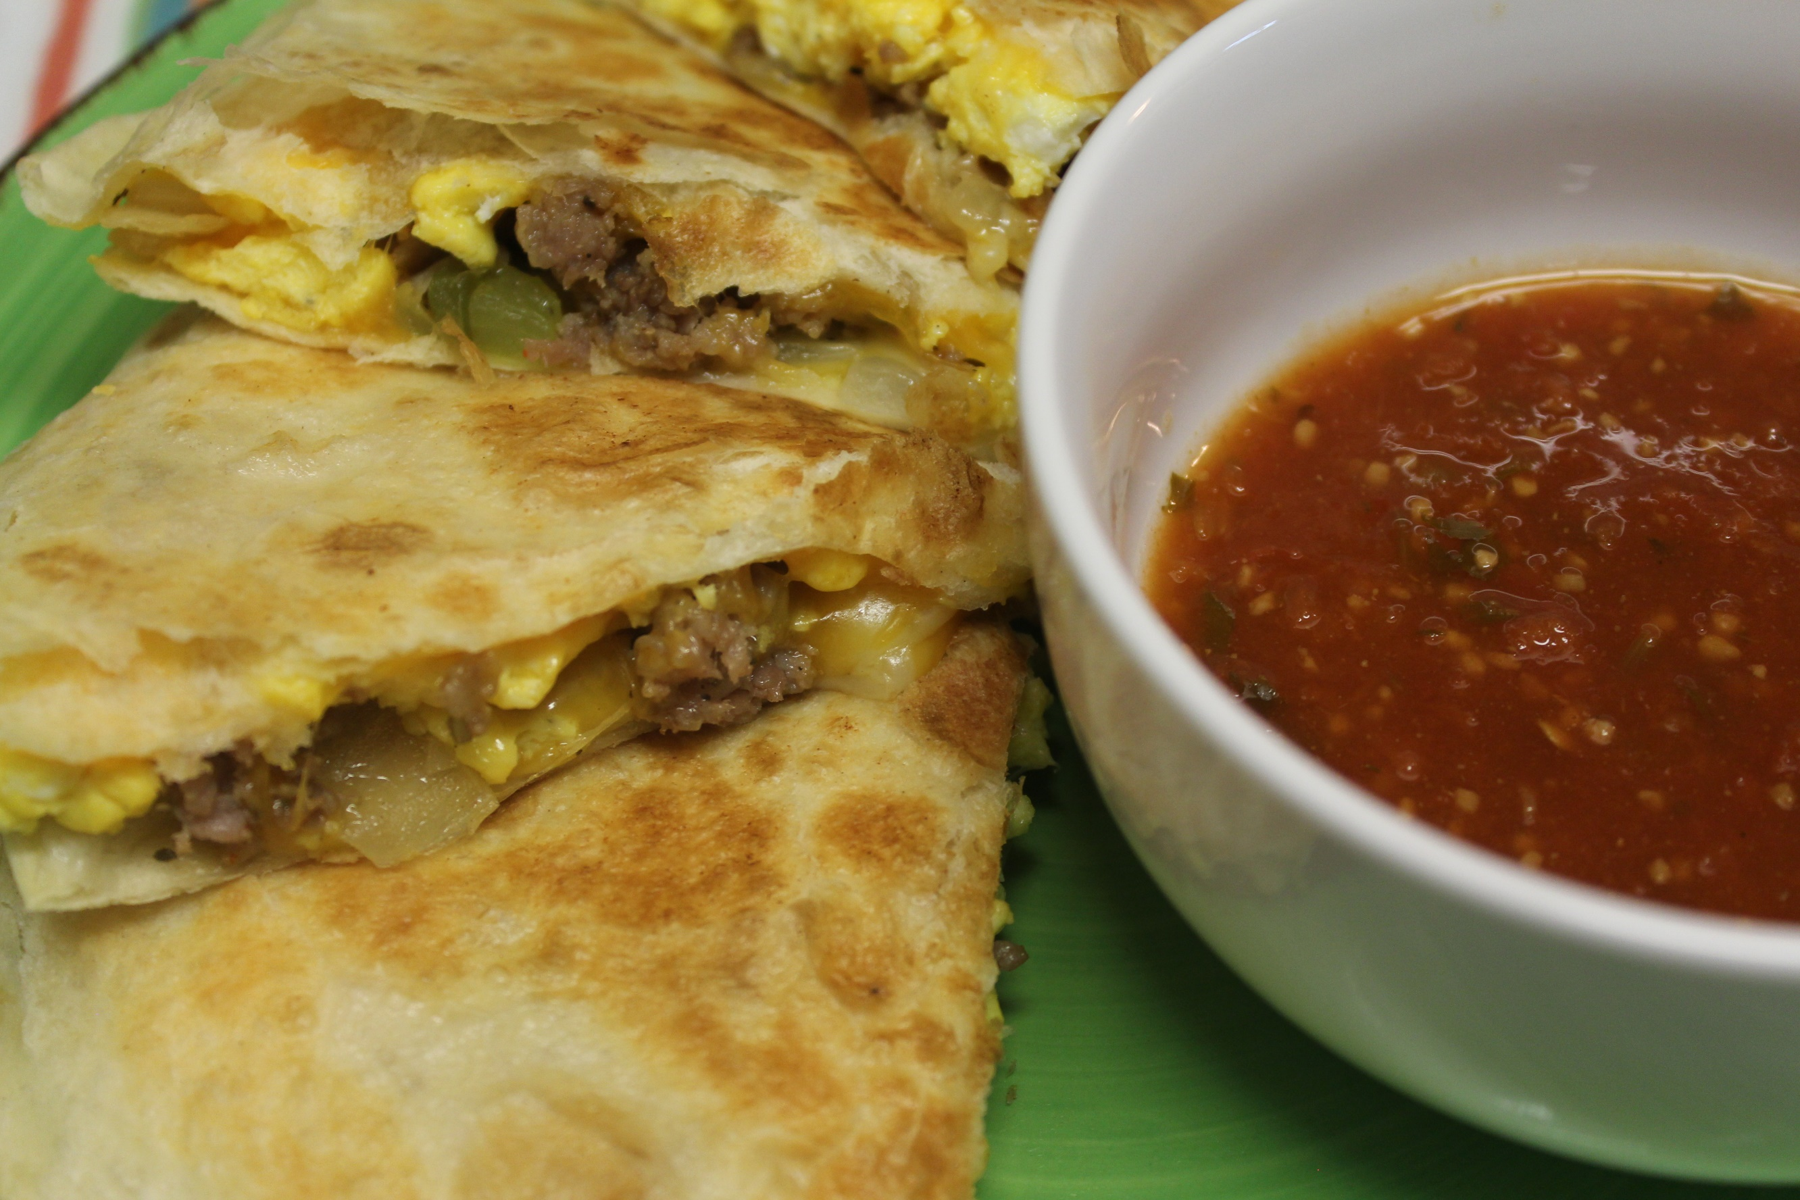
1 lb of ground breakfast sausage
½ yellow onion (chopped)
1 green bell pepper (chopped)
2 Tbsp butter (divided)
5 eggs (scrambled)
2 cups shredded cheddar cheese (approx.)
At least 10 soft flour tortillas
Salt and pepper to taste

Directions:
- Place sausage in a skillet on medium high heat and brown until there are no traces of pink. (I like to fry mine until some crust forms.)
- Remove meat from the skillet with a spoon.
- Add in chopped onion and bell pepper.
- Sauté until softened. Remove from the skillet.
- In a small skillet or pan, add 1 Tbsp of butter. Once melted, add in eggs.
- Sprinkle in some salt, pepper, and about a handful of shredded cheese.
- Scramble eggs to your liking. Remove from heat.
- Now it’s time to build your quesadilla! Place ½ Tbsp of butter in a skillet.
- Put in one tortilla then top with cheese, eggs, sausage, onions, bell pepper, and more cheese.
- Top with another tortilla. Use a plate to flip the quesadilla over to brown on the other side.
- Once brown on both sides, put quesadilla in a plate and cut into fourths.
- Serve and enjoy!
*I like mine with salsa! You could also add avocado, spinach, or even hot sauce!

