Southern Style Candied Yams
Ingredients
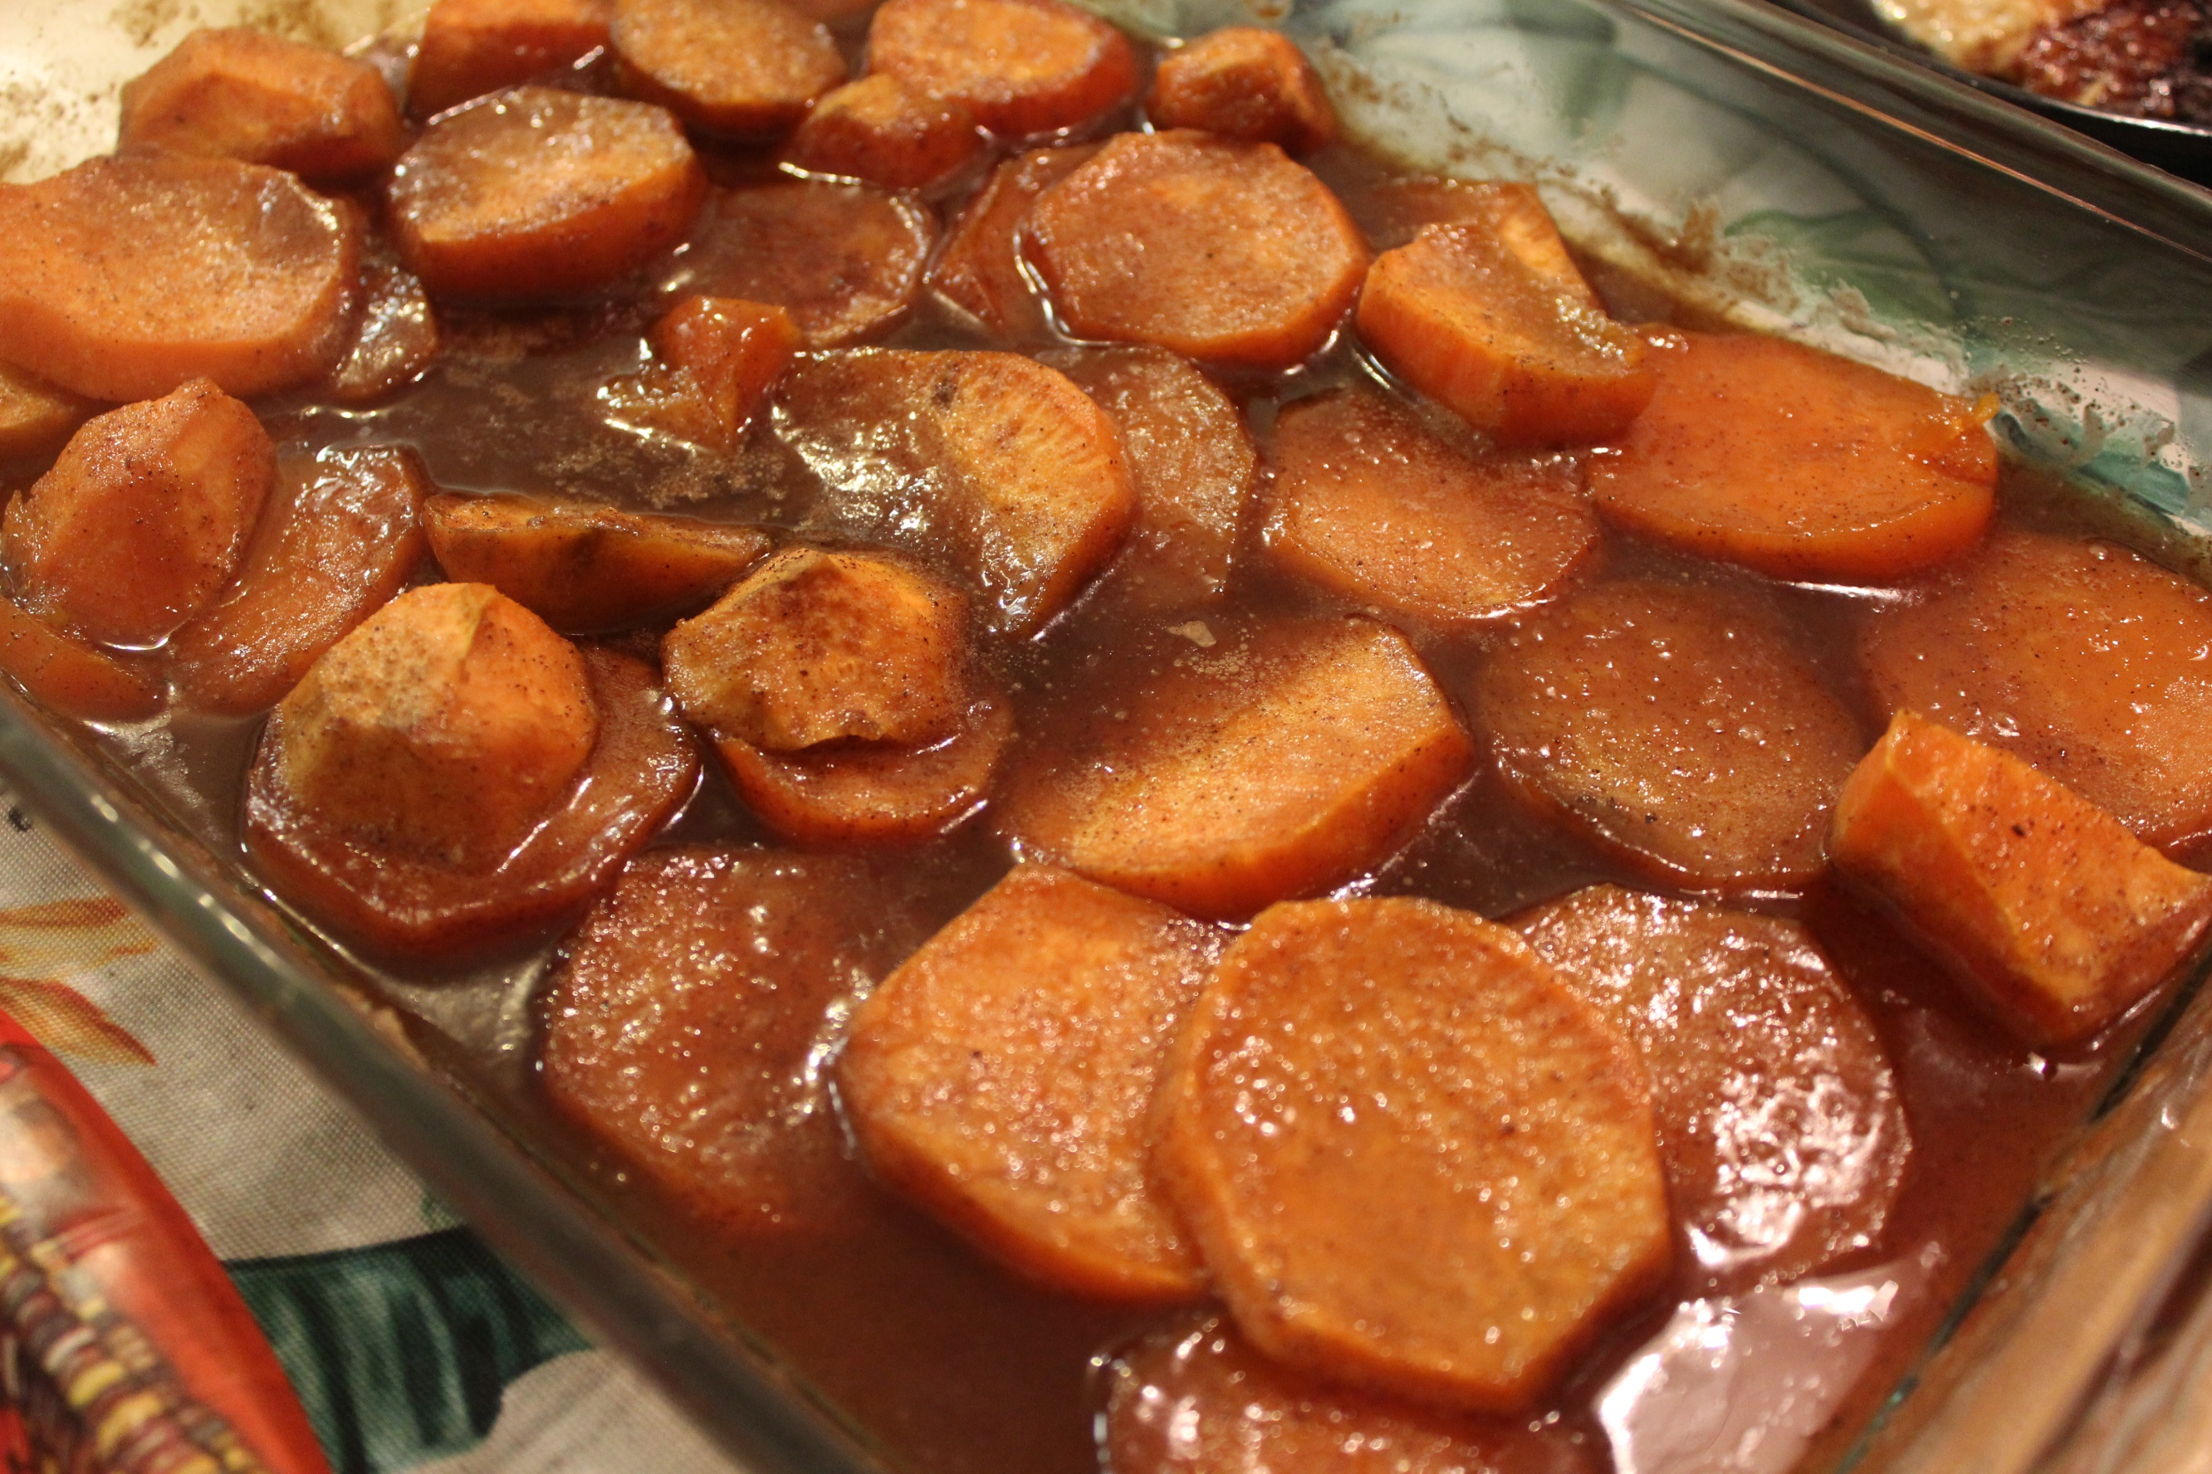
4 - 5 Sweet potatoes
1 Stick of butter
1 cup granulated sugar
1/2 cup brown sugar
1 tsp. ground cinnamon
1/2 tsp. nutmeg
1/4 tsp. ground ginger

Instructions:
- Preheat oven to 350 degrees.
- Peel and slice sweet potatoes (about an inch thick).
- Place sliced sweet potatoes in a 9 X 13 baking dish (or whatever you have).
- Melt butter in a sauce pan on medium heat.
- Add sugars, cinnamon, nutmeg, and ginger. Stir.
- Heat for a few minutes until bubbly.
- Pour mixture over potatoes. Make sure you spread it evenly.
- Cover with foil and place in the oven for 30 minutes.
- Uncover the potatoes. Baste potatoes with sauce to make sure all the potatoes are moist and covered.
- Place back in the oven uncovered for 15 - 20 more minutes.
- Enjoy!!!

