Cheesy Chicken Spaghetti
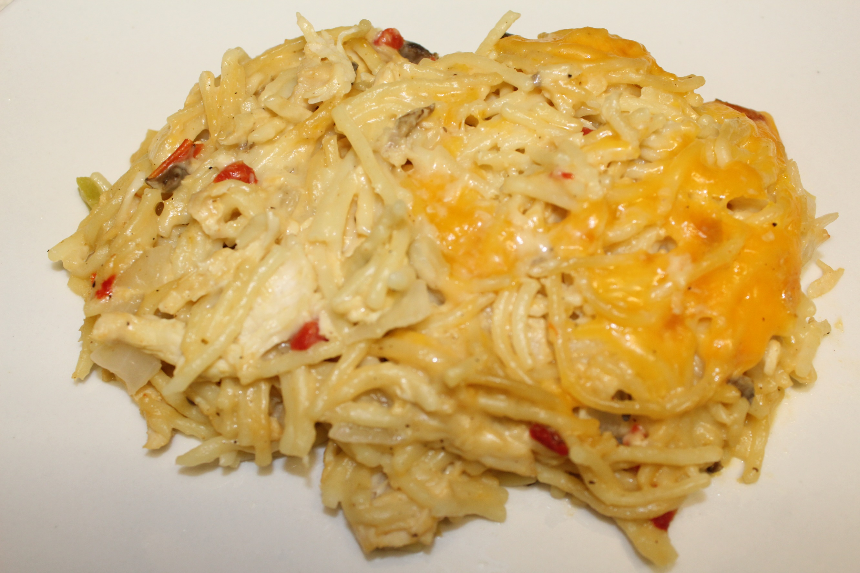

Ingredients
3-4 boneless chicken breasts (you can use any cut of chicken you like)
1 package (12 oz) of thin spaghetti
1 jar (4 oz) of pimientos
1 small onion
1/2 finely diced green bell pepper
2 cans cream of mushroom soup
2 - 3 cups grated cheddar cheese (bagged shredded cheese works too)
1 tsp. seasoned salt (or to taste)
1 tsp. ground black pepper (or to taste)

Instructions:
- Preheat oven to 350 degrees.
- Place chicken in a pot and cover with water.
- Bring to a boil on medium high heat. Boil for 20 - 25 minutes.
- Remove chicken from the pot and set aside to cool.
- Remove two cups of the chicken broth from the pot and set to the side.
- Bring remaining broth back to a boil and add spaghetti. Break noodles into three's and cook al dente.
- While spaghetti is cooking, go ahead and dice onion and bell pepper.
- Drain the pimientos.
- Shred chicken with two forks.
- Drain spaghetti and discard liquid.
- Place cooked spaghetti in a large bowl and add cream of mushroom soup.
- Then add two cups of cheddar cheese.
- Add the pimientos, onion, and bell pepper.
- Add your seasonings.
- Finally, add chicken and broth. Stir.
- Taste to make sure it's seasoned to your liking.
- Pour mixture into a glass baking dish or baking pan.
- Sprinkle remaining cheese on top.
- Bake for 35-40 minutes (until cheese is bubbly).
- Serve and enjoy!!!

