Peach Chipotle Wings
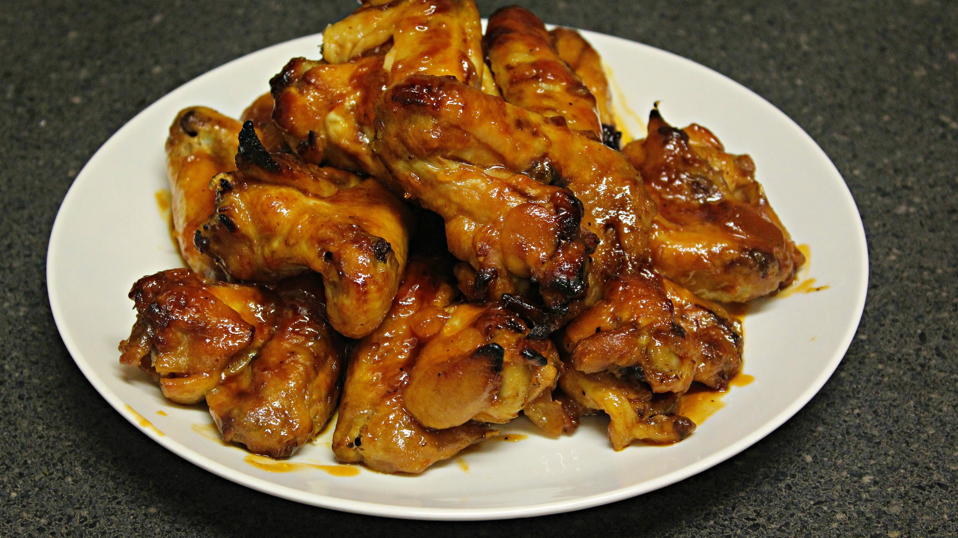
Ingredients:
10-12 chicken wings (or 2-3 lbs wingettes)
9 oz honey chipotle barbecue sauce (I like Sweet Baby Ray's)
9 oz peach preserves
aluminum foil (optional)

Directions:
1.Rinse chicken and place in you slow cooker on high for 2 1/2 hours.
2. Remove chicken from slow cooker, pour out cooking drippings, place chicken back in.
3. Pour barbecue sauce and peach preserves in a small bowl. Mix until well combined.
4. Pour barbecue mixture evenly over chicken. Move chicken around so that each piece is coated in the sauce.
5. Continue to cook on high for another thirty minutes.
6. Preheat oven to 425 degrees Fahrenheit.
7. Place wings on a foil lined cookie sheet.
8. Spoon sauce from slow cooker over each wing.
9. Place chicken in the oven for 15 minutes.
10. Serve and enjoy!

