Red Beans & Rice
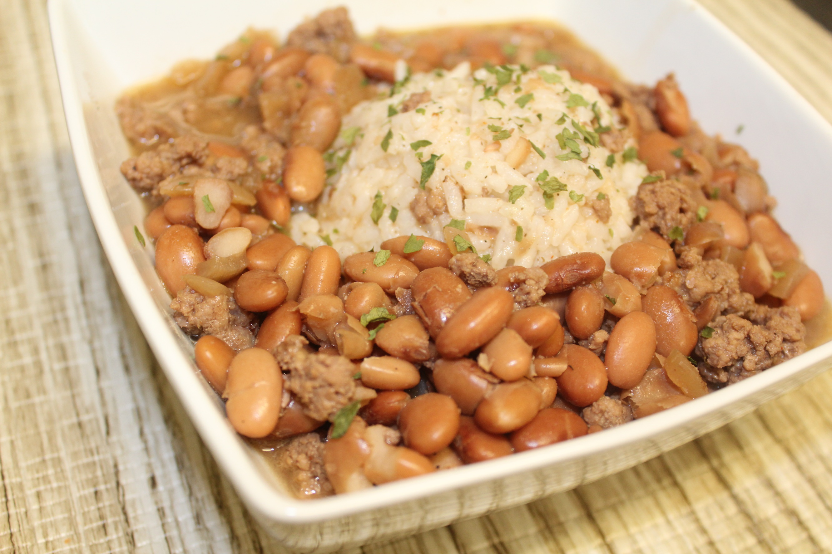
Ingredients
1-2 cups dry pinto beans
1 smoked ham hock (or smoked turkey leg)
1 medium yellow onion
6 cups water (approx.)
1 Tbsp. salt
1 Tbsp. pepper
1 Tbsp. garlic powder
1 Tbsp. Cajun seasoning
1 lb ground beef
1 cup white rice
parsley flakes (garnish)

Instructions:
​1. Clean your beans under running water and sort them. (make sure there are no rocks or weird looking beans.
2. Pour beans in the crock pot along with smoked ham hock and chopped onion.
3. Pour water on top of the beans (I usually pour about an inch above the beans making sure the ham hock is covered).
4. Cover and cook on low for 8-10 hours. (I like to prepare these at night before I go to bed and let it cook all night.)
5. Brown your ground beef in a skillet on medium heat (until no pink is present). Drain and pour it in the crock pot; stir.
6. Prepare your rice according to package instructions.
7. Taste your beans to make sure it's seasoned to your liking. If it's too bland, add more seasonings.
8. Place desired amount of rice in a bowl and top with bean mixture. Garnish with a couple of sprinkles of parsley flakes. (You can also pour rice directly in the pot, if you prefer.)
9. Serve with sweet yellow cornbread and enjoy!
*I like mine with Cayenne pepper sauce or Louisiana hot sauce.

