Southern Style Cornbread Dressing

Ingredients
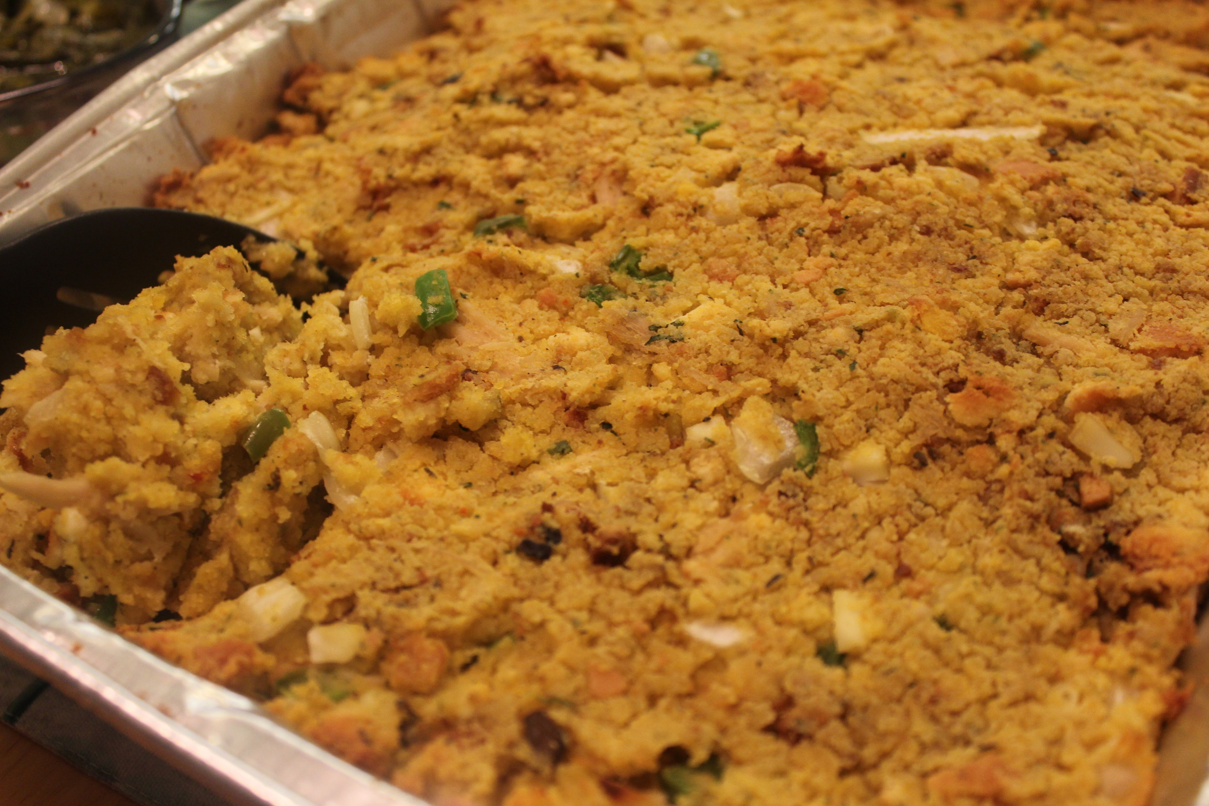
2 yellow cornbread mix
2 Mexican style cornbread mix
1 white cornbread mix
1 box turkey stuffing
1 stick of butter
1 yellow onion (diced)
1 green bell pepper (diced)
3 - 4 hard boiled eggs (chopped)
1 - 2 cups shredded chicken or turkey (as much or as little as you like)
1 can (10.5 oz) cream of mushroom soup
2 - 3 cups chicken (or turkey) broth
Salt (to taste)
Pepper (to taste)
1 tsp. thyme
1 tsp. rosemary
​
Instructions:
- Bake cornbread mixes (white, yellow, Mexican) according to package instructions.
- Cook stuffing according to package directions.
- Preheat oven to 350 degrees Fahrenheit.
- Combine all your breads and crumble together in a large baking dish. Add in the stuffing.
- Add butter, onion, bell pepper, eggs, chicken (or turkey), cream of mushroom soup, broth and seasonings. Mix until well combined.
- Be sure to taste the mixture to make sure it's seasoned to your liking.
- Even out mixture with a spatula.
- Bake for 30 - 45 minutes or until the edges turn golden brown.
- Serve with your favorite cranberry sauce and enjoy!

