Easy Homemade Beef Chilli

Ingredients:
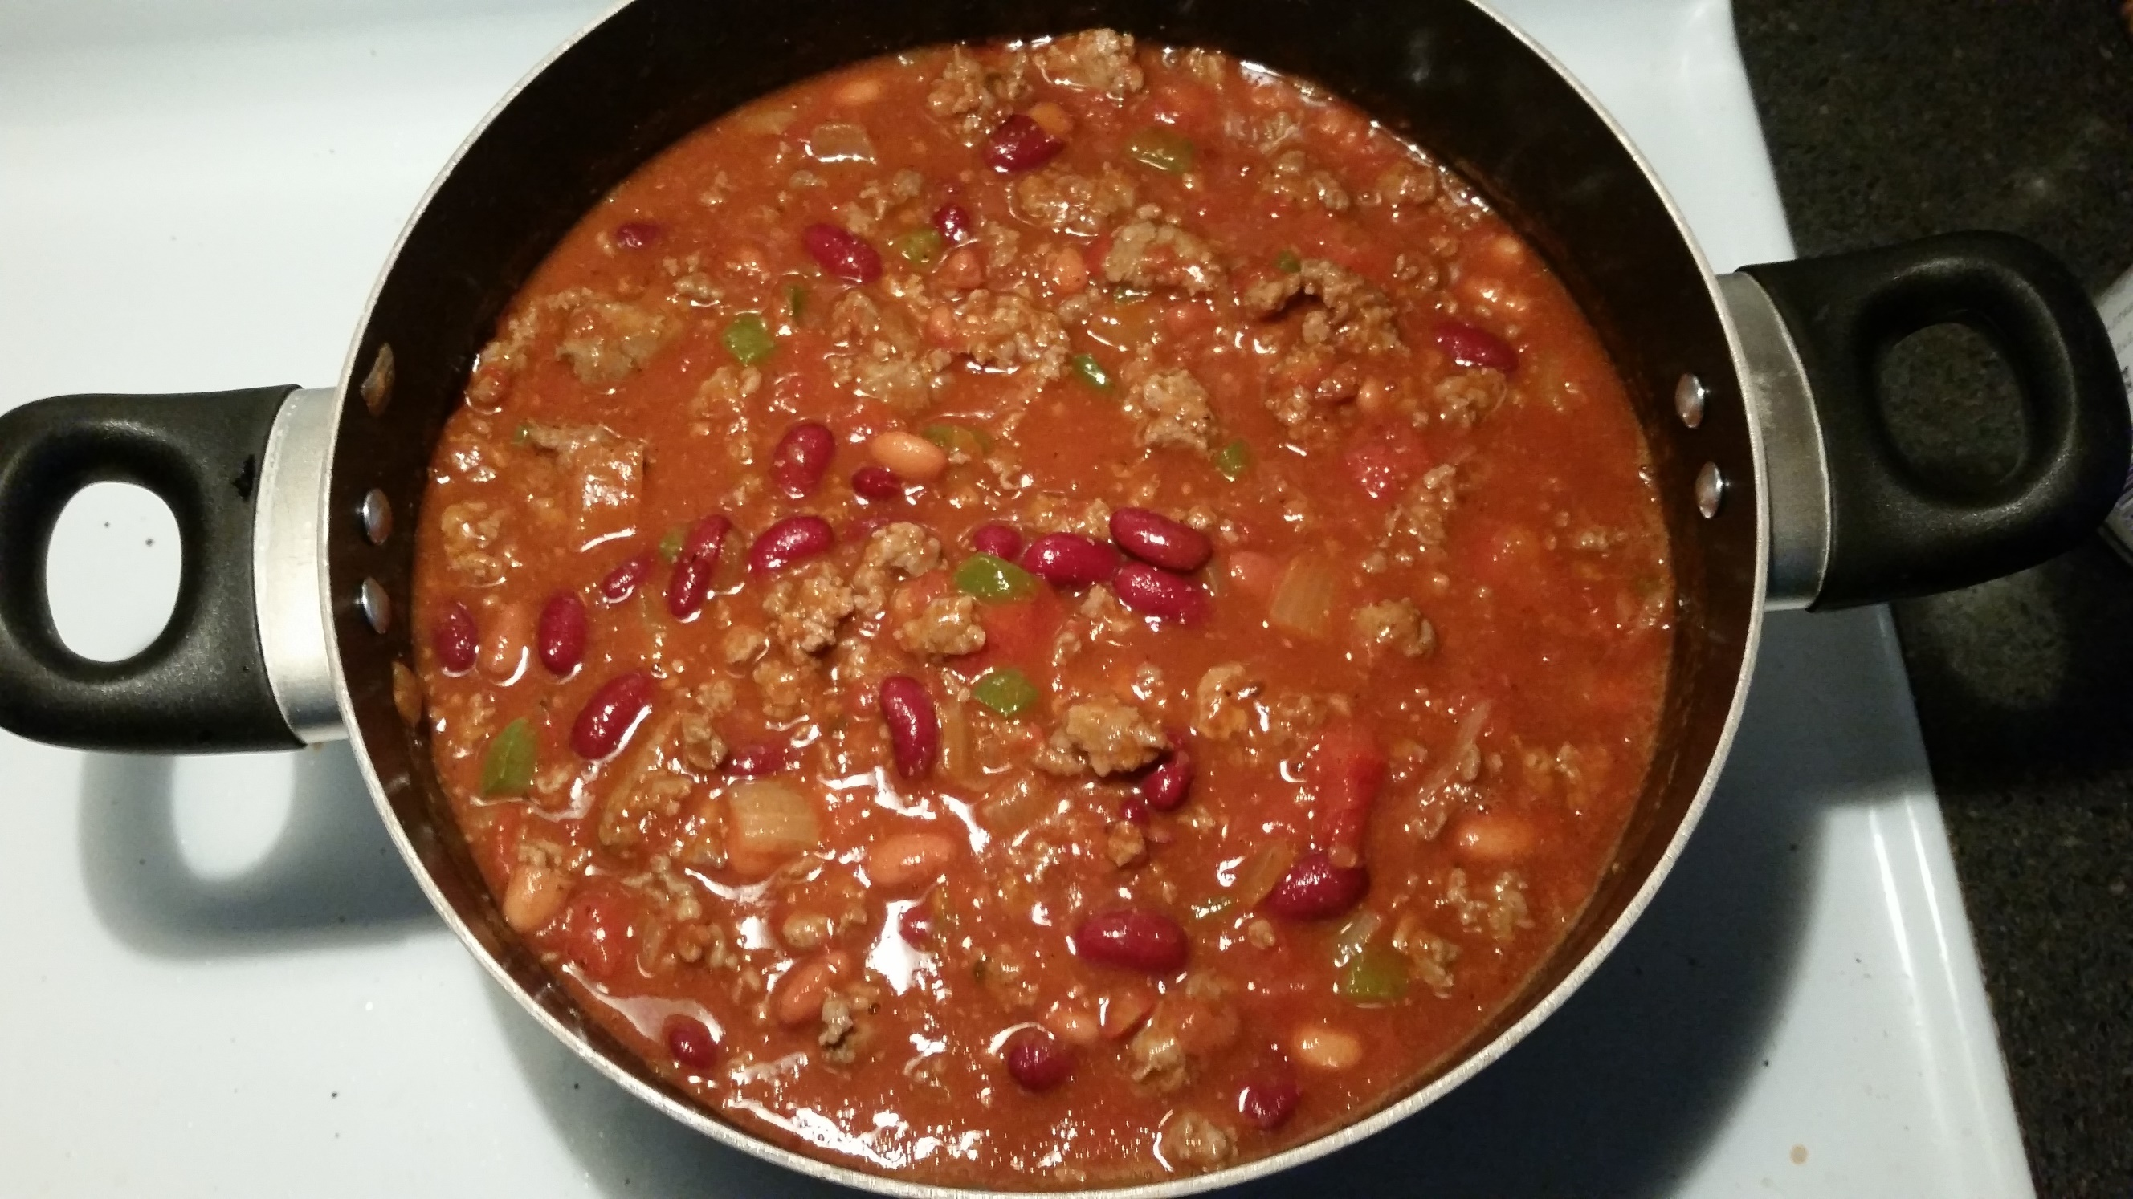
1 lb Ground beef
1 Medium onion, chopped
1/2 Green bell pepper, chopped (optional)
2 Cans (15 oz) tomato sauce
1 Can (16oz) of kidney beans
1 Can (16 oz) of pinto beans
1 Can (10 oz) diced tomatoes
1 McCormick chilli seasoning pack
Pinch of sugar
Salt and Pepper to taste
​
Instructions:
1. Place ground beef in a skillet and brown on medium heat.
2. Add in chopped onion and bell pepper. Cook meat until there are no traces of pink; drain.
3. In a large pot, pour in beef, onions, tomato sauce, beans, diced tomatoes, seasoning, sugar, salt and pepper.
4. Cover and let simmer on medium heat for about 15-20 minutes.
5. Serve with shredded cheese, crackers, and/or sweet cornbread.
6. Enjoy!

