Creamy Tuscan Chicken

Ingredients:
4 Chicken thighs
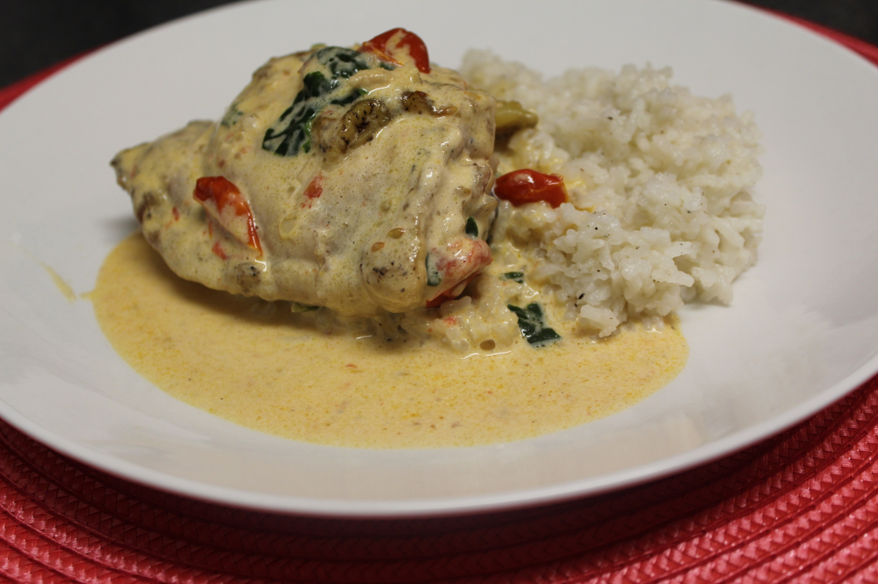
Salt & Pepper (to taste)
1 Tbsp oil
3 garlic cloves, chopped
½ onion, diced
1 tomato, diced
2 cups spinach
2 cups heavy cream
1 tsp salt
1 tsp pepper
½ cup grated parmesan
2 tbsp parsley, chopped

Instructions:
- Season the chicken with the salt and pepper.
- Heat oil in a skillet over medium-low heat.
- Place chicken thighs (skin side down) in the skillet and cook for about 13 minutes. Skin should be crisp. Move chicken around occasionally so it doesn’t stick.
- Flip the chicken, then cook for about 15 more minutes (or until chicken is fully cooked.
- Remove from the pan and add in chopped garlic and onion.
- Stir until garlic is softened. Then stir in tomatoes and spinach until wilted.
- Add heavy cream, salt, and pepper. Bring it to a boil.
- Add parmesan cheese and parsley. Stir until sauce is thickened.
- Place chicken back into the skillet and spoon sauce on top of the chicken.
- Serve and enjoy!
*I like to serve this with white rice or pasta.

