Honey Barbecue Wings

Ingredients:
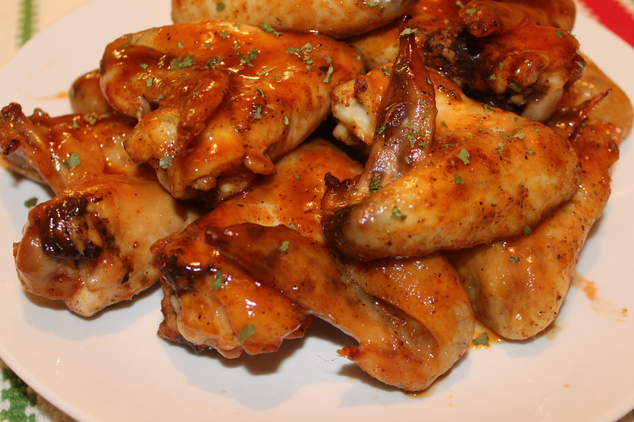
15 chicken wings (or 30 wingettes)
1 tsp. salt
1 tsp. garlic powder
1/2 tsp. sugar
1/2 tsp. paprika
1/2 tsp. black pepper
1/4 tsp. cayenne pepper (1/2 tsp. if you want a little more kick)
cooking spray
(For the sauce)
1 cup hickory smoke barbecue sauce
1/2 cup honey
2 Tbsp. ketchup
2 Tbsp. Louisiana hot sauce
1 Tbsp. brown sugar
4 Tbsp. butter
1/2 tsp. garlic powder
Instructions:
- Preheat oven to 375 degrees.
- Rinse chicken under running water and pat dry with a paper towel.
- Mix salt, garlic powder, sugar, paprika, black pepper, and cayenne then sprinkle it on the chicken. Rub it in to make sure the chicken is evenly coated.
- Spray a cookie sheet (or baking pan) with cooking spray and place chicken on pan.
- Bake in the oven for 40 minutes (turn the chicken over after 20 minutes).
- While the chicken is baking, stir barbecue sauce, honey, ketchup, hot sauce, brown sugar, butter, and garlic powder in a small sauce pan on medium low heat.
- Simmer for 20 - 30 minutes, stirring occasionally.
- Once chicken is done, coat chicken evenly with the sauce and place back in the oven for 5 - 10 minutes (until the sauce is bubbly).
- Serve with your favorite dipping sauce and enjoy!

