Banana Egg Rolls

Ingredients
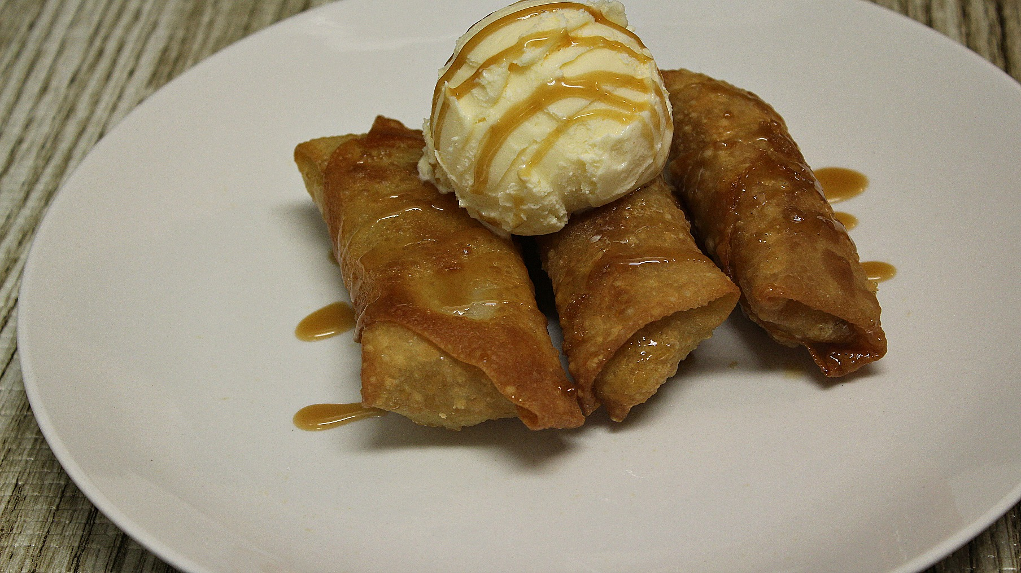
2 Bananas (or plantains)
8 Spring roll wrappers
Brown sugar
Vegetable oil for frying
Caramel syrup

Instructions
- Cut bananas into fourths (the long way).
- Place one fourth of the banana on one corner of the spring roll wrapper.
- Sprinkle about a tbsp. of brown sugar on the banana.
- Roll the banana up in the spring roll wrapper tucking the sides in as you go.
- Dab a little water on the end to seal the egg roll.
- Place enough oil in a skillet to reach half the egg rolls.
- Brown on both sides (2 – 3 minutes per side).
- Serve with vanilla ice cream and drizzle with some caramel syrup.
- Enjoy!

