Banana Pecan Bread Pudding

Ingredients
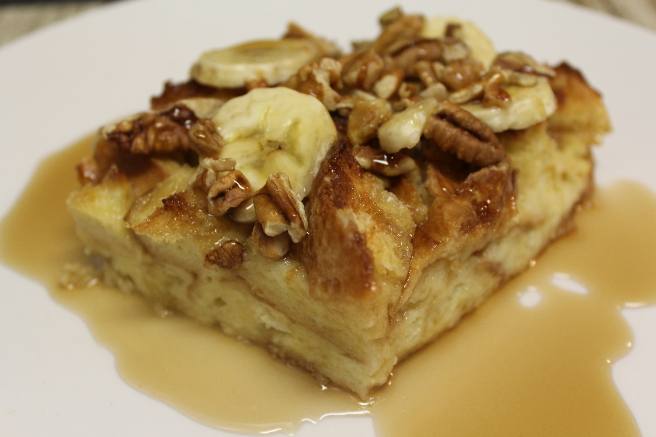
1 loaf of French bread
3 cups of whole milk
1 cup of sugar
2 Tbsp brown sugar
1 tsp of salt
1 Tbsp vanilla extract
6 eggs
¼ cup unsalted butter (melted)
2 bananas
Chopped pecans (desired amount)
Maple or pancake syrup (desired amount)

Instructions
- Cut bread into one inch cubes.
- Spray a 13x9 inch dish with cooking spray and place the bread in the dish.
- Mix together the milk, sugar, brown sugar, salt, vanilla, eggs, and melted butter until well combined.
- Pour the mixture over the bread.
- Lightly press the bread down in the mixture with a spoon.
- Cover and place in the refrigerator for 1 ½ hours.
- Preheat oven to 350 degrees.
- Bake in oven for 45 – 50 minutes or until puffed up and golden brown.
- Slice up bananas and place on top.
- Sprinkle on some chopped pecans.
- Pour desired amount of syrup on top.
- Serve warm and enjoy!

